**STUDENT DATABASE**

CREATE TABLE Person_table(id int,FirstName varchar(255),descriminator varchar(255));

insert into person_table values('1','lokesh','student');

insert into person_table values('2','loke','student');

insert into person_table values('3','guru','student');

insert into person_table values('4','sarguru','student');

insert into person_table values('5','arun','student');

insert into person_table values('6','yokesh','student');

insert into person_table values('7','mukesh','student');

insert into person_table values('8','gurunath','student');

insert into person_table values('9','sargur','student');

insert into person_table values('10','varun','student');

select * from person_table;

create table Student_grade(id int,course varchar(20),grade decimal(3,2));

insert into student_grade values('1','mysql','1.0');

insert into student_grade values('2','sql','7.0');

insert into student_grade values('3','mysql','6.0');

insert into student_grade values('4','sql','9.0');

insert into student_grade values('5','sql','8.0');

insert into student_grade values('6','sql','3.0');

insert into student_grade values('7','mysql','2.0');

insert into student_grade values('8','mysql','8.0');

insert into student_grade values('9','sql','1.0');

insert into student_grade values('10','mysql','5.0');

select * from student_grade;

create table person_data (Name varchar(10), Course varchar(10), Grade decimal(3,2))

insert into person_data (Name, Course, Grade)

(Select a.firstname as name, b.course, b.grade from person_table a LEFT OUTER JOIN student_grade b on a.id = b.id)

select * from person_data;

select b.name, b.course,b.grade from (select distinct course ,min(grade) as min ,max(grade)as max from person_data group by course) as c inner join person_data b on b.course=c.course and (b.grade=c.min or b.grade = c.max) order by grade desc;

OUTPUT:

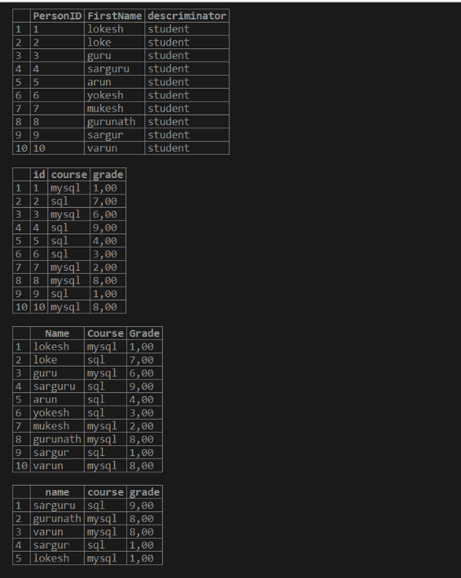

LINK

<https://rextester.com/ZAAOIK48338>